Didactic Surgery Laboratory # 2

20-22 May 2008

Exploratory Celiotomy and Ovariohysterectomy
Kidney and Lymph Node Biopsy

OBJECTIVES

1. To familiarize the student with the correct handling and use of common surgical instruments and suture materials.

2. To introduce the student to the proper technique for a ventral midline incision and abdominal wall closure.

3. To introduce the student to the systematic approach of exploring the peritoneal cavity in a thorough and reproducible manner.

4. To allow the student to become familiar with the normal anatomy of the peritoneal cavity so that in the future the abnormal will be more apparent.

5. To give the student the opportunity to perform an ovariohysterectomy and become familiar with the surgical anatomy.

6. To give the student an opportunity to practice tissue handling and suturing techniques.

Note: The suture material to be used for each procedure is listed in the document “VMS 6072 Suture Material Assignments 2008.doc”. You may post the suture assignment list on the wall of your cubicle if you desire. Please refer to the suture assignments so that you are using the correct suture material for each part of the laboratory.
Pertinent Anatomy

A thorough knowledge of the normal anatomy of the abdominal cavity is necessary to perform a safe, effective celiotomy. The student should review Miller's Anatomy of the Dog to become completely familiar with the following structures and their relationship to each other in the abdominal cavity. The vascular supply to each of the structures should also be reviewed.

Diaphragm liver lobes gall bladder
Stomach greater curvature lesser curvature
Pylorus pancreas common bile duct
spleen duodenum jejunum
jejunal arcades ileum ileal artery
lymph nodes cecum colon
kidneys adrenal glands phrenicoabdominal v
mesoduodenum mesocolon ureters
urinary bladder prostate gastrohepatic lig
duodenocolic lig ovaries proper lig of ovary
uterine horns uterine body cervix
uterine arteries broad ligament round ligament
inguinal rings epiploic foramen bladder ligaments
falciform lig aorta caudal vena cava
linea alba greater omentum xiphoid cartilage
portal vein peritoneum external rectus sheath

EXPLORATORY CELIOTOMY

Indications for exploratory celiotomy include, but are not limited to, biopsy of abdominal structures, relief of gastrointestinal obstruction, removal of previously diagnosed disease such as neoplasia, confirmation of suspected disease processes, alleviation of urinary tract obstruction, exploration of penetrating wounds of the peritoneal cavity, repair of hollow viscus ruptures, repair of diaphragmatic hernias, removal of diseased reproductive tracts, removal of retained testicles, treatment of peritonitis, and treatment of diseases of the retroperitoneal space.

The dog's bladder should be expressed just prior to surgery to avoid inadvertent cystotomy when entering the abdominal cavity. The surgical preparation should include a wide clip (from cranial to the xiphoid to caudal to the brim of the pelvis and lateral to the mammae to at least the level of the ventral border of the ribs) and an adequate surgical scrub.

The surgical field is quadrant draped to allow a midline incision extending from the xiphoid to the brim of the pelvis. The edge of each lateral drape should be approximately 2 cm from the proposed skin incision. (In male dogs the prepuce may be clamped with a towel clamp to the side opposite the surgeon prior to placement of the lateral quadrant drape on that side. Be careful to not contaminate your gloved hand during this maneuver). The caudal drape should just cover the scrotum in male dogs. A full paper drape should be placed over the quadrant drapes and fenestrated.

Perform a sponge count prior to making your incision and have your anesthetist record the number of sponges and laparotomy pads with which you are starting. Count any additional sponges you receive during the procedure and have the anesthetist add them to the original count.

The skin incision begins at the xiphoid and continues caudally to the brim of the pelvis. If the patient is a male dog, the skin incision is curved slightly just cranial to the prepuce on the side adjacent to the surgeon and is continued as a paramedian incision to the brim of the pelvis. The preputial branches of the external pudendal vessels will require double ligation and transection on the side of the paramedian skin incision in male dogs.

The linea alba is identified following minimal if any undermining of the subcutaneous tissue (extensive undermining creates more dead space). Such identification of the linea alba is achieved by using a push cut of the Metzenbaum scissors to remove the subcutaneous fat off of the linea alba. The fat attaches to the linea alba bilaterally; therefore, a push cut is necessary on the left and right margins of the linea alba. In the male dog, the preputial muscle must be incised in the area of the ligated branches of the external pudendal vessels so that the prepuce can be reflected laterally to expose the caudal aspect of the linea alba. The linea alba is elevated using thumb forceps and a stab incision is made using the scalpel with the sharp edge of the blade pointing upward. The incision in the linea alba may be continued to the limits of the skin incision using a scalpel and groove director (thumb forceps) or Mayo scissors. Extending the lineal incision beyond the limits of the skin incision will make closure of the linea alba difficult. Incision off of the midline will also make closure difficult; paramedian incisions require more time and effort to suture closed due to the appositional problems.

The falciform ligament and ventral ligament of the bladder should be identified. Each should be removed at its origin on the ventral midline to facilitate visualization. Excise the falciform ligament bilaterally. At the cranial aspect excise the falciform off the dorsal surface of the xiphoid process. Access the dorsal side of the xiphoid by grasping the falciform and pulling it in a cranial direction until the xiphoid process everts cranially. Be careful to avoid incising the diaphragm while cutting the falciform fat off of the xiphoid process. Bleeding from the falciform ligament excision may require ligation or electrocoagulation, particularly when excision is caudal to the xiphoid. The above described excision from the dorsal surface of the xiphoid process rarely results in significant bleeding. Laparotomy sponges are placed on each side of the incision to cover all exposed skin and protect the tissues from damage by the Balfour retractors. When placing the Balfour retractors, be sure that no viscera are trapped between the blades of the Balfour and the abdominal wall.

The success of an exploratory celiotomy depends on an organized and systematic approach. There is no single mandatory method of exploration; however, the surgeon must develop the same routine for each patient so that no aspect of the exploratory celiotomy is overlooked. Examine the abdominal contents in situ before exteriorizing any structures. Inspect all parietal peritoneal surfaces for pathological changes such as petechiation or carcinomatosis. Examine the diaphragm, the lobes of the liver and the gall bladder. Many surgeons express the gall bladder to ascertain patency of the common bile duct; however, expressing the gall bladder is not as easily achieved as expressing the urinary bladder and is not necessary. One of your faculty surgeons (Mann) prefers to apply the “Pillsbury Doughboy Test”. That is, gently poke the gallbladder with your index finger. It should indent and spring back to normal position. Failure to indent means that the gall bladder is overly distended due to obstruction. [If you are truly concerned about bile duct patency, perform a duodenotomy and cannulate the duct via the major duodenal papilla.] Examine the gastrointestinal tract beginning at the esophageal hiatus and continuing aborally to the rectum. The greater omentum will need to be reflected cranially to run the bowel. Pay particular attention to the pylorus, short mesenteric root to the duodenum, the duodenocolic ligament, the vascular supply to each section of the bowel (to identify the segment of intestine), and the ileocecocolic junction. After examining the bowel, inspect the spleen and the left and right lumbar gutters. "Anatomical" retractors should be used to visualize the lumbar gutters: the mesoduodenum (for the right) and the mesocolon (for the left). Elevating each of these structures clears the respective lumbar gutter and allows inspection of the kidney, adrenal gland, ureter, and reproductive tract. While elevating the mesoduodenum identify the epiploic foramen which is bordered by the vena cava, portal vein and hepatic artery.

Other structures to examine include the pancreas, bladder, prostate, mesenteric lymph nodes, vena cava, and portal vein. Repeat the inspection of the abdominal cavity until you are satisfied you know the location of all the viscera and their blood supply. Be able to identify all structures mentioned in the anatomy section.

OVARIOHYSTERECTOMY
Since we have started with an incision for exploratory celiotomy you will not be able to utilize the landmarks for making the skin incision for routine ovariohysterectomy or realistically practice using the Snook hook in this laboratory session. During a subsequent laboratory, you will start with a limited approach in order to practice the procedure as described below.

Ovariohysterectomy

Liberally clip the ventral abdomen from the mid-thorax to the vulva. Clip laterally to the fold of the flank lateral to the mammae.

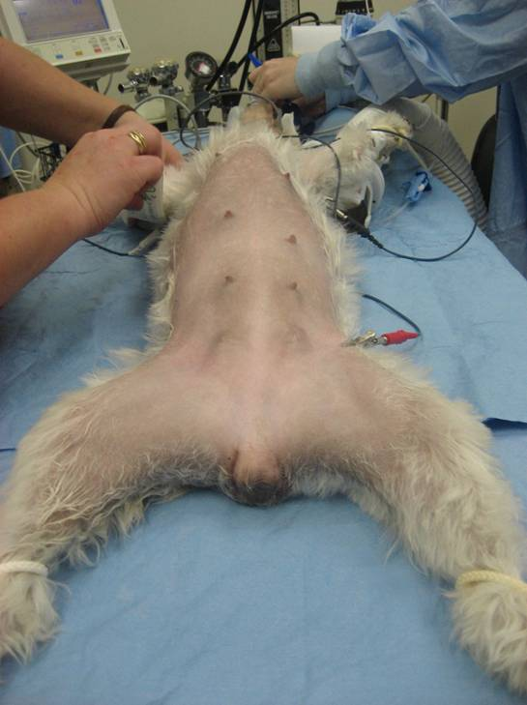

Palpate the urinary bladder. Gently express it if it contains urine. Bladder expression might be more easily achieved with the dog in lateral recumbence. Apply pressure on both sides forcing the urine caudally to the trigone area. Continue to increase pressure until the urethral sphincter relaxes and urine starts to flow. Maintain the pressure on the sides of the bladder until it is empty. You must be careful because excessive pressure will traumatize the bladder and result in hematuria. It is better to wait and aspirate the urine intraoperatively than risk iatrogenic injury.

Prep the skin and then drape. Apply the four quarter drapes first. Method 1: Apply the cranial and caudal drapes first. The cranial drape should be at the base of the xiphoid cartilage. The caudal drape should be at the cranial brim of the pelvis. The lateral drapes are applied next. Method 2: Place the quarter drapes in the following order: (1) caudal, (2) lateral, (3) cranial, and (4) lateral, clamping at each corner as you go. Lateral drapes should be approximately 2 cm from the midline (just medial to the nipples). Apply towel clamps at each corner. Next apply the full paper drape and fenestrate it.

The general guidelines for locating the ovariohysterectomy skin incision are as follows:

Method 1:

1. Divide the distance between the umbilicus and pubis into thirds.
2. Dog: Make the incision from the center of the front third to the center of the middle third. In deep chested dogs the incision must be shifted (or extended) further cranially.
3. Cats: The incision covers the middle third. (It is easier to exteriorize the ovarian pedicles and more difficult to exteriorize the uterine body in cats compared to dogs.)

Method 2

Method 2:

Using your nondominant hand (not the dominant hand as demonstrated here), place your thumb on the cranial aspect of the pubis and your fifth finger on the umbilicus. Identify the midpoint between your fifth finger and thumb with your index finger. Your index finger is now indicating the caudal extent of your skin incision (dog). Incise from just caudal to the umbilicus to the point identified by your index finger. In cats, your index finger indicates the middle of your skin incision. In other words, make the skin incision in cats more caudally to better exteriorize the uterine body.
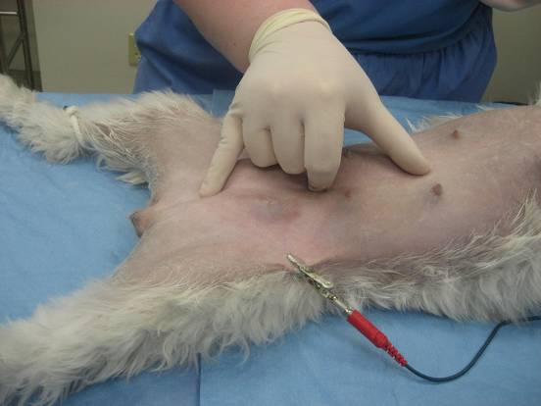
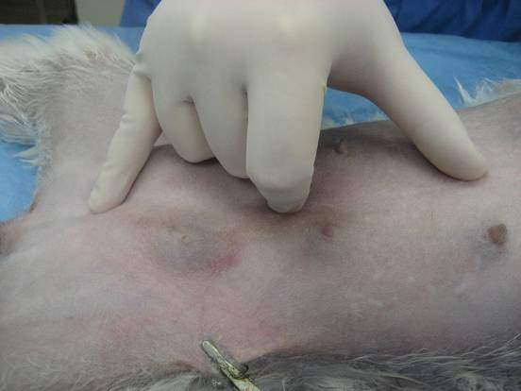

NOTE: For this laboratory we are making a long incision so you can review the surgical anatomy. Make the incision as described for exploratory celiotomy. The incision should extend from just cranial to the xiphoid to the cranial brim of the pelvis.

Use a finger and thumb of your nondominant hand to tense the skin and apply lateral pressure as you incise the skin. Apply enough pressure to in incise the full thickness of the skin. Continue the incision caudally with one continuous motion.

Control bleeding from subcutaneous vessels with mosquito hemostats or digital pressure. Use sponges with a dabbing motion rather than a wiping motion. Wiping may remove blood clots sealing smaller vessels and causes unnecessary tissue trauma. Try to apply the hemostats to just the blood vessel.

Continue the dissection down through the subcutaneous tissue with Metzenbaum scissors and thumb forceps until the linea alba is visualized. Excise the subcutaneous tissue from the linea alba. Avoid undermining. Undermining creates dead space which will predispose to seroma formation postoperatively. As you become more experienced, undermining will rarely be necessary.
Hemostat application

Undermining
(to be avoided)

The linea alba is very thin in cats and in the caudal part of the abdomen in dogs, making visualization more difficult.

The abdominal cavity is entered by tenting the external fascia upward with thumb forceps and then making a stab incision through the linea alba with the scalpel blade. Note: The blade of the scalpel faces upward so that when it penetrates the abdominal cavity the risk of damaging the abdominal contents is reduced.

The stab incision should be made at the cranial aspect of the incision near the umbilicus, if possible, because the fat in the falciform ligament at this location offers additional protection against iatrogenic injury. Once the opening is large enough to accommodate a finger, palpate for adhesions to the ventral midline cranially and caudally.

The most efficient way to extend the incision is to insert the tips of the thumb forceps into the abdomen (top) or use a groove director (bottom) to protect the underlying structures as you incise the linea alba with the scalpel.
The thumb forceps and scalpel blade should be moved in tandem so that the incision is completed with one continuous motion. The arrows indicate the direction of cutting.

Alternatively, the linea alba incision can be extended using Mayo scissors. Be sure to keep the tip of the scissors against the linea alba as they are inserted into the abdomen. The linea alba is generally too tough to cut with a push-cutting motion.

NOTE: LABORATORY #2 …
Once the abdomen is open, place moistened laparotomy sponges on each side of the abdominal incision and insert the Balfour retractors. Perform your exploratory celiotomy before continuing with the ovariohysterectomy.

Pertinent anatomical structures during ovariohysterectomy:
1. Kidneys
2. Ureters
3. Suspensory ligament of the ovary
4. Ovary
5. Ovarian vascular pedicle
6. Proper ovarian ligament
7. Uterine horns
8. Uterine body
9. Uterine arteries
10. Mesometrium (broad ligament)
Proper ovarian ligament
11. Round ligament of the uterus

The Snook ovariohysterectomy hook is used to retrieve the uterus. Insert it into the caudal part of the incision. Keep the hook faced outward (laterally) against the body wall. When it reaches the deepest point, turn the hook medially and sweep the hook toward the midline and slowly withdraw it. If resistance is felt, stop, release the tissue and try again. If intestine or omentum is exteriorized, replace the structure into the abdomen and try again. Initially, you may exteriorize either the uterus or the broad ligament. Gently retract the broad ligament until the uterus is visualized. Use your fingers to gently exteriorize the remainder of the uterine horn.

Use the ovariohysterectomy hook for retrieving only the first ovary. Using it for the second ovary frequently results in entangling the urinary bladder with the reproductive tract.

The broad ligament has a smooth glistening appearance while the omentum has a dull “granular” appearance. You should try to visualize this difference. Learning this difference can you save a lot time when performing this procedure through a smaller incision. Many times the Snook hook will catch the broad ligament rather the uterus itself. If you identify the broad ligament, you can follow it to the uterus.

NOTE: LABORATORY #2 … Since you made a long incision for this laboratory it will be difficult to use the Snook hook as intended. You will get more practice with the Snook hook in a subsequent laboratory.

Identify the ovary and uterine horn
before applying any clamps.

Place a mosquito hemostatic forceps on the proper ovarian ligament to aid retraction of the ovary. Hold the mosquito forceps in your dominant hand in such a way as to prevent inadvertent caudal traction that could result in premature tearing of the ovarian pedicle. Use you nondominant hand (thumb and index finger) to strum and eventually tear the suspensory ligament from its attachment on the dorsal body wall.
proper ligament

Place a mosquito hemostat on the proper ovarian ligament at this location.

Slide the index finger of your nondominant hand down the lateral aspect of the suspensory ligament as far as possible. Apply increasing pressure in a caudomedial direction until the ligament breaks. Use the flat part of your index finger on the cranial surface of the ligament. If you get your finger on the side of the ligament you are more likely to poke a hole in the mesovarian and possibly lacerate the ovarian vessels rather than rupturing the suspensory ligament. This is a common error made by novice surgeons.

Alternatively, insert your index finger as described above and then insert your thumb to grasp the suspensory ligament between those fingers as far down in the abdomen as possible. Use a twisting motion break the ligament.

Sharp transection of the suspensory ligament is generally avoided since the blood vessels in the suspensory ligament will bleed more when this technique is used.

You should be able to exteriorize the ovary and part of the ovarian pedicle when the suspensory ligament has been adequately broken down.

The ovarian pedicle typically contains a lot of fat in addition to the vessels. Look for a clear area in the broad ligament caudal to the pedicle and make a window with the tips of your Carmalt forceps. Make sure all branches of the ovarian artery will be included.
Use the Carmalt forceps intended for the ovarian pedicle to create the window in the broad ligament between the ovary and uterine horn. [Do not use scissors as shown in this picture.]

Then, place this Carmalt forceps as clamp #1 as illustrated in the following figures.

Since you have only 4 Carmalt forceps, use Kelly hemostats for clamp #3 and Carmalts for clamps #1 and #2.

Place clamp #1 on the ovarian pedicle leaving enough room to place clamp #2 between clamp #1 and the ovary.

Place clamp #2 between clamp #1 and the ovary, leaving approximately 5 mm space between clamps #1 and #2. Always hold the ovary in your fingers while applying clamps #1 and #2 to be sure all ovarian tissue will be excised.

Place clamp #3 across the uterine horn near the proper ovarian ligament (after removing the mosquito forceps from the proper ovarian ligament).

Transect the ovarian pedicle between the ovary and clamp #2 before placing the ligature. Transecting the pedicle first makes manipulations easier, but if your clamps slip (unlikely) the pedicle will retract back into the abdomen. Leaving the ovary attached during ligature application actually creates a false sense of security because tissues can tear at any clamp even if the clamp does not slip. Transecting the ovary first allows for less manipulation during ligature placement and, therefore, less chance of tearing tissue at the clamps.

Note: ALWAYS check to make sure that all of the ovary has been excised before proceeding further. If you are unsure, open the ovarian bursa so you can visualize the ovary directly.

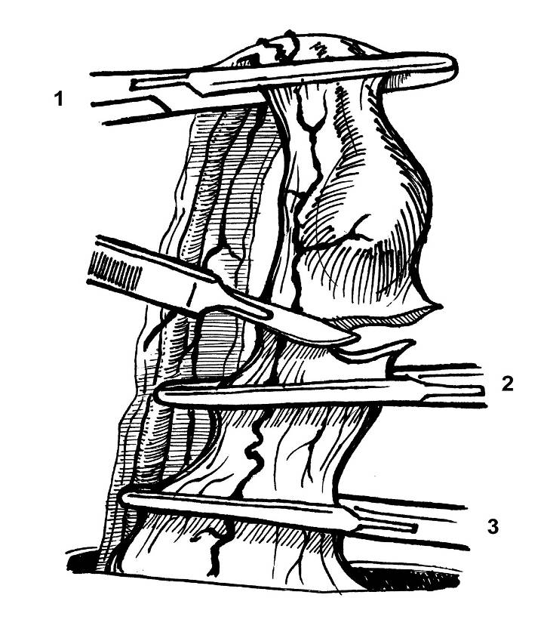

3
3

The mosquito forceps has been removed from the proper ovarian ligament.

2
2

The distance between clamps #1 and #2 is exaggerated.

1
1

mmmmm
Pedicle ligation – Method 1 – Miller’s knot

Place a double overhand throw (the type of Miller’s knot you have learned) proximal to the first clamp.
(See your suture list for the appropriate material.)

See illustration of the double overhand throw (Miller’s knot) below. Review the PowerPoint presentation on the Miller’s knot as needed.
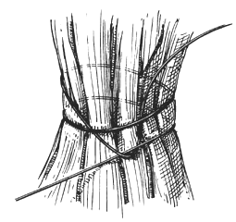
Miller’s knot

Since the ovarian pedicle may contain a lot of fat, the double overhand throw offers increased security with less likelihood of the knot loosening as a result of tension. [NOTE: In cats and small dogs without much fat in the ovarian pedicle, a surgeon’s throw can be used in place in of the Miller’s knot. Square knots without a surgeon’s throw may also be used in small cats and dogs.]

Regardless of what you choose for your first throw, have your assistant remove the bottom clamp (#1) as you start to tighten the knot so that your suture will slide into the area crushed by the clamps.

Tighten the first throw completely. Then, place three additional throws to complete the knot.

In large dogs and dogs with a lot of fat in the ovarian pedicle, a second (circumferential) ligature can be placed.

This figure shows the circumferential ligature being placed distal to the first ligature [i.e., between the first ligature and remaining clamp (#2)]. In this case the ligature must be far enough away from the clamp to avoid the tissue spreading effect of the clamp.

Pedicle ligation – Method 2 – Transfixation suture

If this technique is utilized, the most proximal (deepest) ligature should be a circumferential ligature. This is done to reduce the risk of bleeding if a vessel is inadvertently lacerated while placing the suture through the ovarian pedicle.

The technique demonstrated in the drawing uses a figure-eight suture for the transfixion ligature: Place back end of needle (or bluntly push the tip of a mosquito hemostat) through the center of the pedicle (1 to 2). [This reduces the risk of lacerating the vessels in the pedicle.] Loop the suture around one side of the pedicle (3 to 4). Redirect the needle back through the same hole in the center of the pedicle (5 to 6). Loop the suture around the other half of the pedicle (7 to 8). Securely tie the ligature.
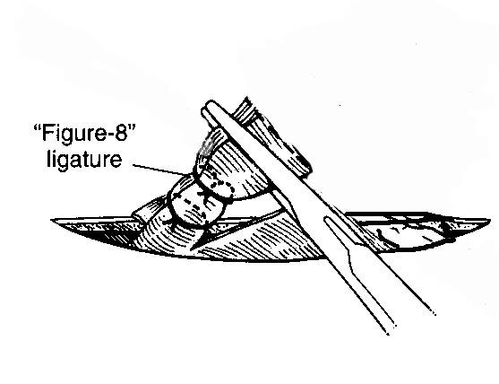
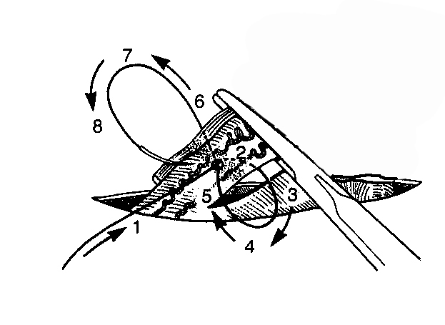

Circumferential ligature
Grasp the ovarian pedicle with
thumb forceps before releasing clamp #2.

Observe for bleeding. If none is seen let the pedicle slowly retract into the abdomen while still grasping it with the forceps. Observe for bleeding. In some instances the upward tension will prevent bleeding while the pedicle is exteriorized, but then bleeding will occur when the tension is reduced. If bleeding is noted, exteriorize the pedicle again and re-apply hemostats prior to attempting another ligation.

If the pedicle slips into the abdomen, retract the duodenum (right side) or colon (left side) medially, identify the pedicle, and grasp it with thumb forceps. Adequate exposure usually requires extension of the abdominal incision. NEVER apply crushing clamps until the pedicle has been isolated to avoid iatrogenic injury to the ureter.

Trace the uterine horn back to the cervix. Be sure to identify both branches of the uterine artery (the one running adjacent to the uterus and the one out in broad ligament). Create a window in the broad ligament just cranial to the cervix and lateral to the vessels. Bluntly tear the broad ligament from caudal to cranial to mobilize the uterine horn. The round ligament may be difficult to tear.

Exteriorize the opposite uterine horn and repeat the same the procedure. Note: Expose the second uterine horn by tracing from the first horn. This is faster than using the Snook hook again and avoids the potential for entrapment of the urinary bladder or intestine.

Place a Carmalt forceps cranial to the cervix. Make sure you leave enough room so that a secure ligature can be placed. Place additional Carmalts as shown. Be sure to leave enough space between clamps #1 and #2 to allow placement of the transfixion ligatures described below.

Note: It is not necessary to place clamps in cats and small dogs. In fact, the turgid uterus of cats in heat may rupture if clamp placement is attempted.
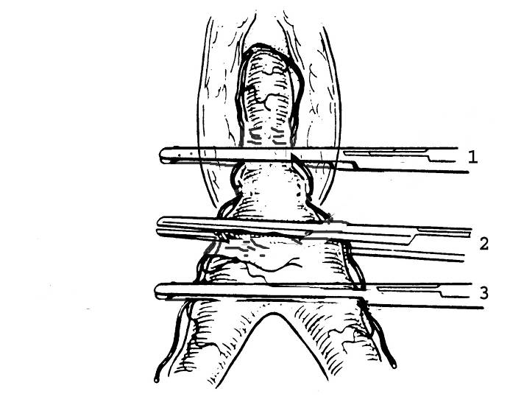

Incise the uterus between clamps #2 and #3. Discard the uterus.
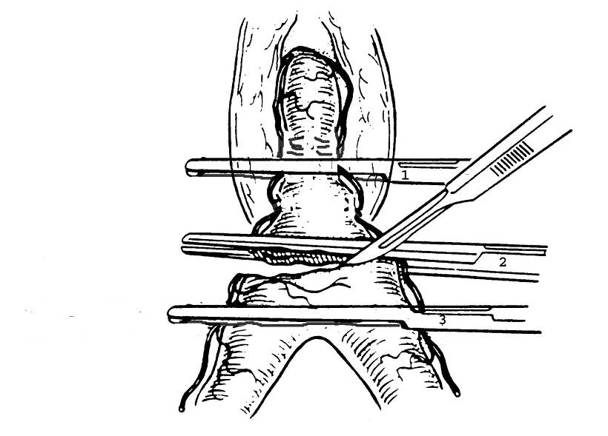

Note: If ligatures are placed without using clamps, a clamp must be placed in the position of clamp #3 prior to cutting the uterus in order control backflow bleeding from the uterus as it is cut.

Place a Miller’s Knot and tighten
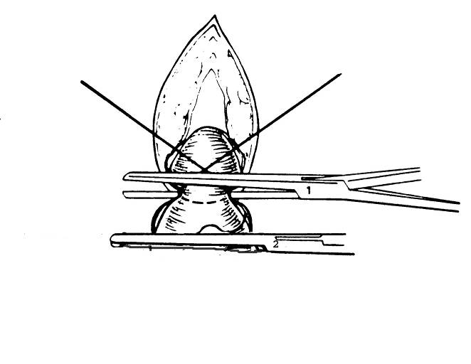
it as Carmalt #1 is removed.

Alternatively, a transfixion ligature can be placed as described previously. In this case the needle can be passed through the uterus in normal fashion because uterine vessels can be readily observed and avoided.

In large dogs, “stick tie” ligatures can be placed on the uterine arteries. Take a small bite in the uterine wall adjacent to the uterine vessels and then ligate the vessels.
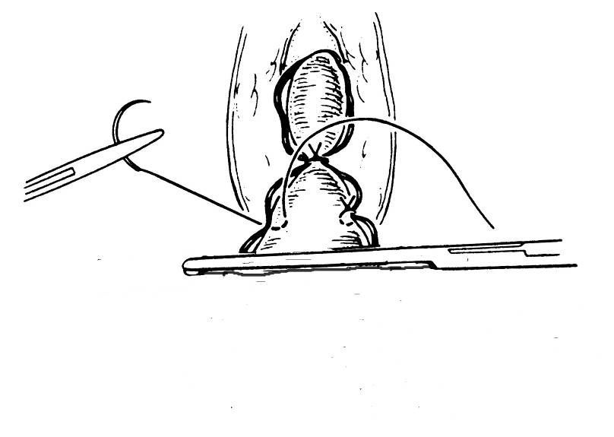
This figure shows placing the “stick tie” distally to the transfixation ligature (or Miller’s knot), but placing the “stick tie” so that it is proximal to the transfixation ligature (or Miller’s knot) would be better.

In small dogs and cats a circumferential ligature can be placed rather than using “stick tie” ligatures.

Grasp the uterine stump with thumb forceps before removing clamp #2. Check for bleeding as the clamp is removed. Slowly replace the uterine stump into the abdomen while observing for bleeding.

The abdomen should always be checked for signs of hemorrhage before beginning the closure. If pooled blood is noted in the abdominal gutters, inspect the ovarian pedicle and uterine stump to rule out active bleeding. Some blood will accumulate as a result of oozing from the torn broad ligament and possibly from blood running down from the incision in the abdominal wall.

Move on to the kidney biopsy if time and instrumentation permits.

Kidney Biopsy

Kidney biopsies can be harvested intraoperatively by excising a wedge of tissue from the kidney(s) or by using a Tru-cut biopsy needle. If there is a focal mass, wedge biopsy is indicated. Otherwise, the Tru-cut is convenient because multiple biopsies can be collected from each kidney. Collect a minimum of two biopsies from each kidney.

Immobilize the kidney with your nondominant hand or the hand of an assistant. Use the Tru-cut needle as described below to obtain biopsies. Apply pressure over the hole in the capsule to control bleeding. Try to collect all of the biopsies through a single hole in the capsule. The needle can be inserted at different angles to biopsy different areas, but penetration of the renal pelvis should be avoided. [The spring-loaded biopsy needle is a little more expensive, but is easier to use, and biopsies will be more consistent, compared to Tru-cut needles that are not spring-loaded.]

Move on to the mesenteric lymph node biopsy if time permits.

Lymph Node Biopsy

While Tru-cut needles could be used for abdominal lymph node biopsies, incisional or excisional biopsies are more commonly performed. The decision whether to perform an incisional or excisional biopsy depends on the location of the node, the number of nodes involved and the potential of damaging adjacent structures. Small mobile nodes are typically excised completely using a combination of blunt and sharp dissection. Blood vessels to the node are ligated as they are encountered.

Locate and biopsy a mesenteric lymph node. Incise the mesentery directly over one pole of the node with Metzenbaum scissors. Be sure to not damage the underlying blood vessels. Continue isolating the entire pole of the lymph using blunt dissection. Place a circumferential ligature around the lymph node to perform a guillotine biopsy. Excise the pole of the lymph node with scissors or scalpel being sure to leave enough tissue to maintain the ligature. You can close the hole in the mesentery with one or two sutures being sure to not lacerate the blood vessels.

Abdominal Closure:

Close the external rectus fascia using a continuous suture pattern. Tie three square knots (six throws) in each end of the continuous suture pattern. Be sure to have an instructor check your closure after the first 3 or 4 suture passes to make sure you are closing the correct layer.

Close the subcutaneous tissue. Be sure to bury the knots at each end. Take a bite down into the fascia every 3rd or 4th suture passage to eliminate the dead space.

Suture the skin using simple interrupted, cruciate, and/or figure-of-eight sutures.

